**User’s Manual for PlantPro**

**Introduction:**

This instruction manual is designed for users who are going to use PlantPro application. Since the development of web application, a verity of applications is designed to satisfy different users’ requirements. And the “PlantPro” is the one of application that focused on people who are interested in plants.

**Pain point:**

We are in a time that using mobile phones and computers becoming the major part of most people's lives, we wanted to develop a product that stands out from the rest. “PlantPro” is an app that encourages users to step outside of the world of electronics and calm down to enjoy nature. In this application, Users can share the plants they found, look through and comment other’s posts and search the plants they want.

**Homepage:**

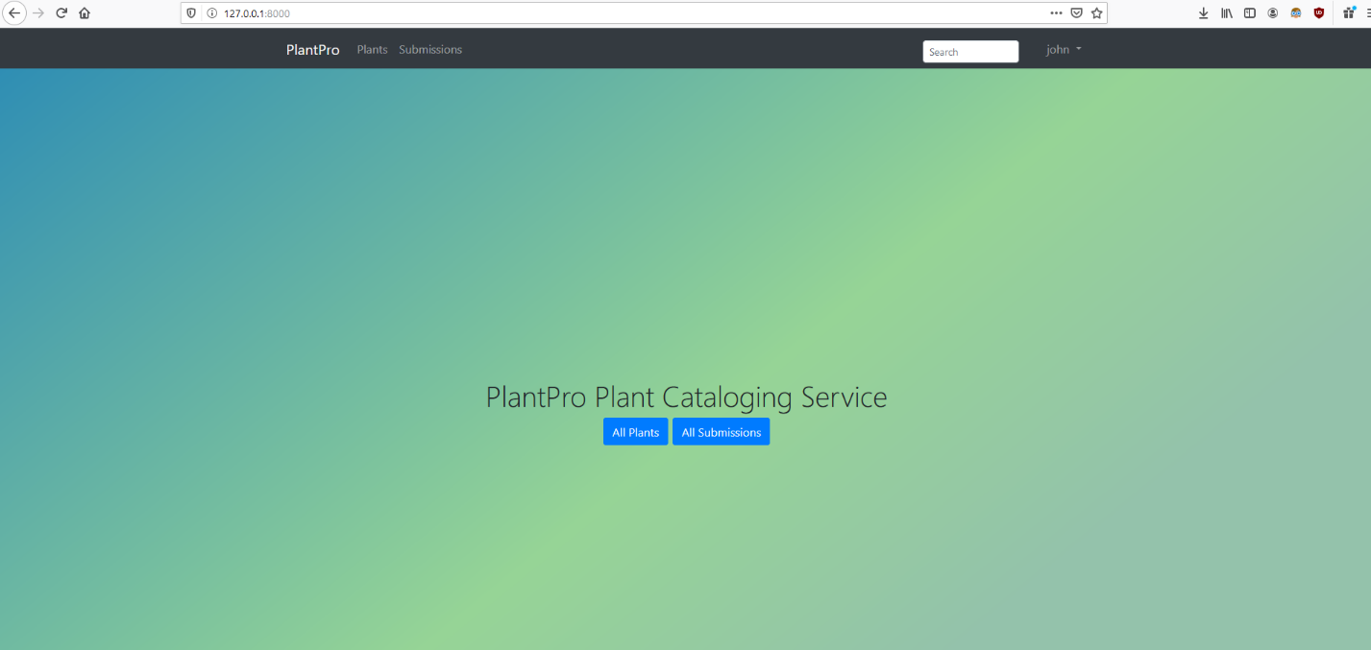

This is homepage of “PlantPro”, which is in a concise style, an obvious navigation bar with all the functions of this application.

(from left to right)

**PlantPro:** a button to negative to the homepage, user can double click it whenever they want to back to homepage.

**Plants:** a button to negative to the page which shows all plants in this application. Users can add plants in this page.

**Submissions:** a button to negative to the page for all submissions from users. Users can also submit plants information (location, description…)

**Search bar:** Users can search any plants that exit on our application by typing keyword of that plant.

**Login:** a button to negative to the login page for users who already have an account to login.

**Register:** a button to negative to the sign-up page for new users who don’t have an account before.

**Note:** if users want to share something on this app, an account is required.

**Step 1: Login/Register**

**Login:**

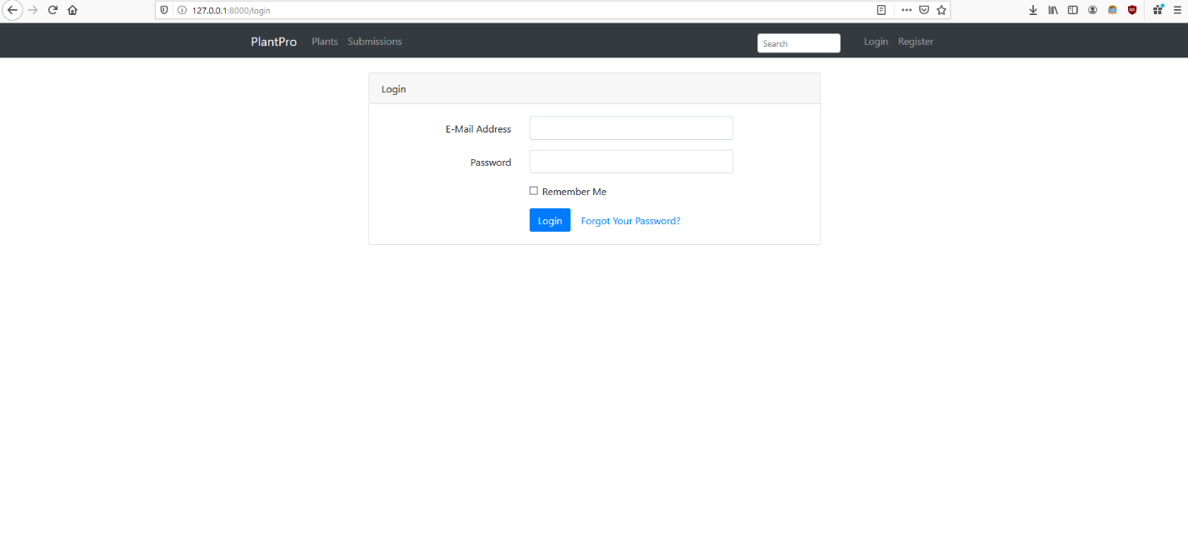

**For user who has an account already**: click the login button on the top right of the page to get into the login page to login.

**Register :**

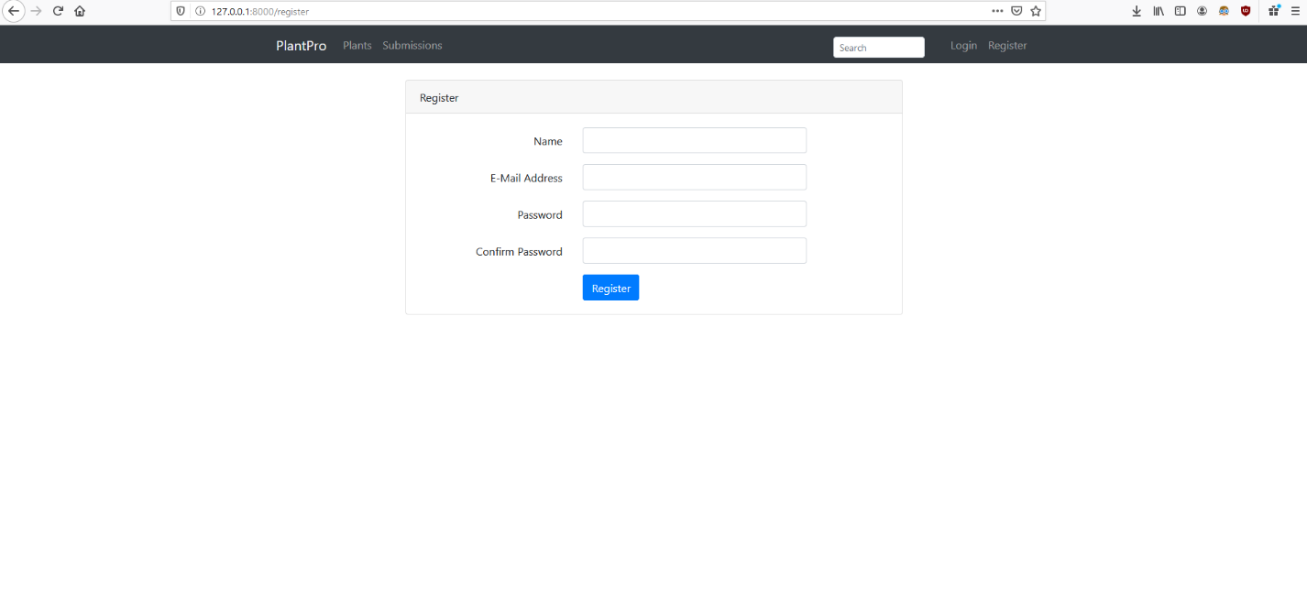

**For new users,** click the register button on the top right of the page to get into the register page to register a new account of “PlantPro”.

**Step 2: Plants/Submissions**

**Page of Plants:**

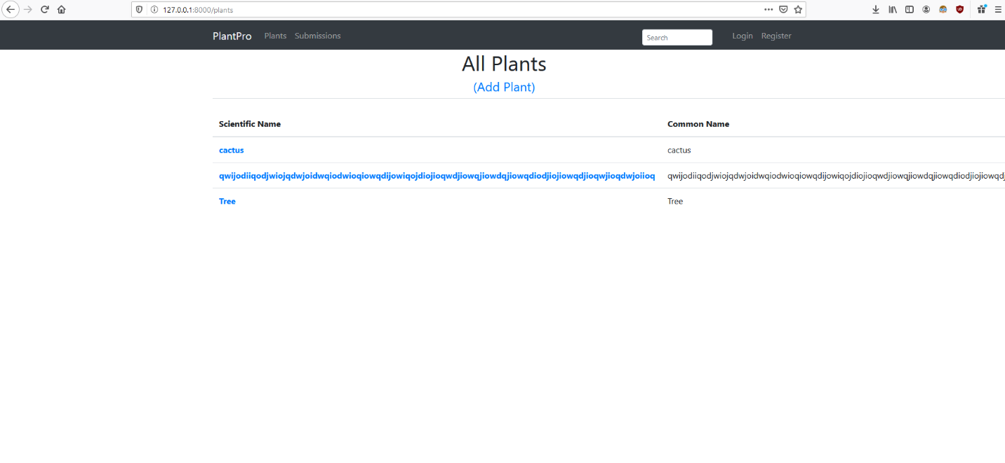

**Plants page** have all plants’ information on our application which submitted by users. User not only can Add Plant here, but also find plants here and make comments of others’ posts and if users likes them, click the triangle button on the top left to upvote. (here are examples below)

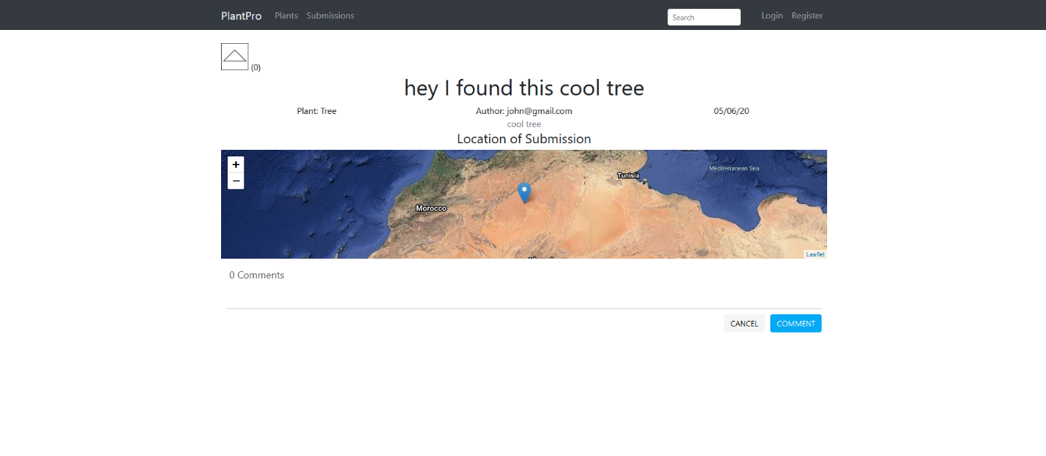 Above is an example of a user’s posts/submissions.

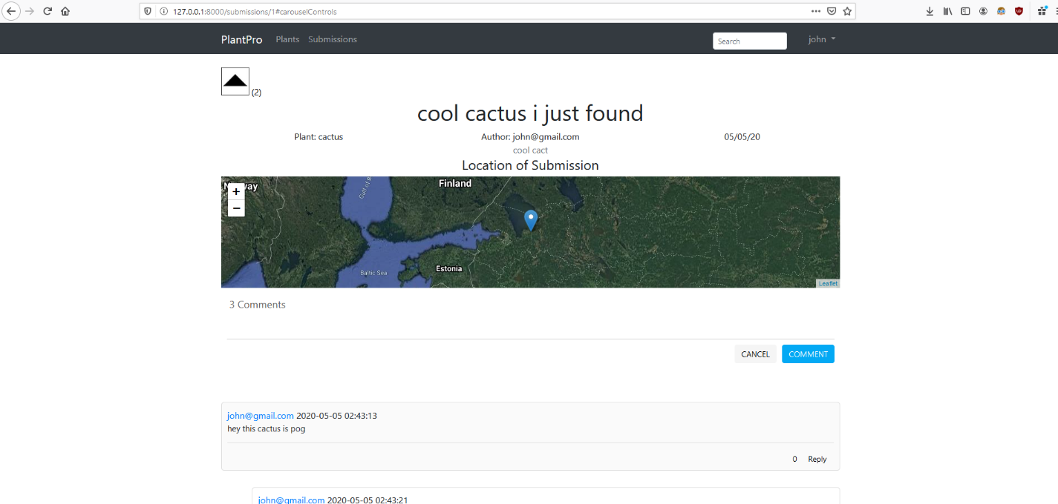

Above is an example of users can comment other user’s posts and upvote it if they like it.

**Page of Submissions：**

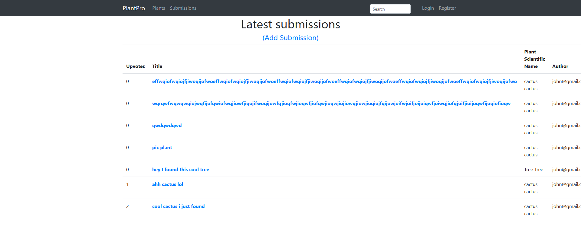

**User can click Add Submission on the page of submission to get into add submission page and add new submission** through filling information of plants on the submission form.

**Step 3 (last instruction of using “PlantPro”): Search bar**

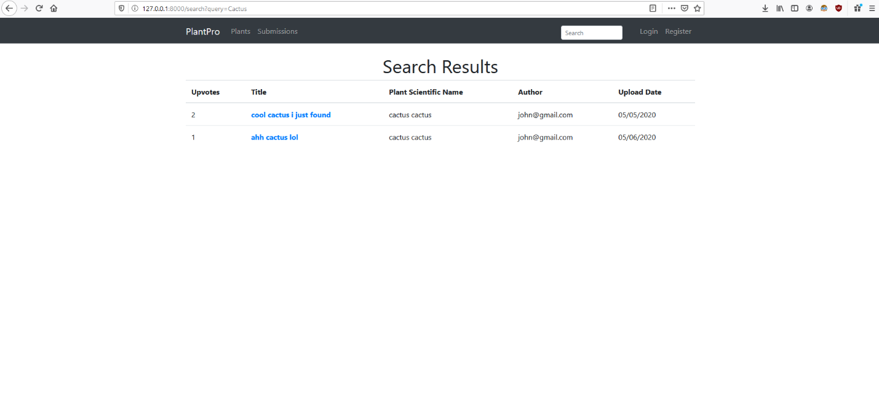

**Users can search any plants on our “PlantPro” application through search bar**, after type in key word of plants, user can click the title which in the search results to get into the page related to the plants they want. (above is an example of searching “cactus”).